USER GUIDE & ARCHITECTURAL MAP

Document 3: Operational Manual, Component Mapping, and User Journey

1.0 The User Journey: From Setup to Secure Communication
The User Experience is designed to be 'Zero-Configuration.' While the underlying cryptography is complex, the user interface remains as simple as a standard messaging app. This section outlines the 'Happy Path' of a new user joining the network.

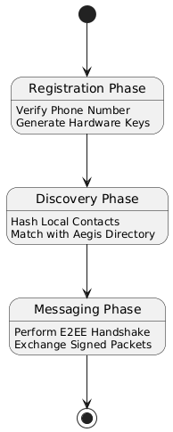
2.0 Onboarding and Verification Workflow
- Step 1: The user enters their phone number. The app explains that this number will be cryptographically secured.
- Step 2: A background process generates the Ed25519 identity key inside the Secure Enclave.
- Step 3: An SMS OTP is received. The app auto-fills the code and submits it to the relay.
- Step 4: The 'Shield' icon lights up, indicating that the number is now bound and protected.

3.0 Interacting with the Handshake System
For the user, 'The Handshake' is experienced as a connection request. When an unknown but verified user attempts to message them, the user receives a notification: 'New Secure Connection Request from +1-555-0123. Accept?'
Accepting the request automatically exchanges public keys and moves the conversation into the 'Secure Inbox.' Blocking the request prevents that specific cryptographic identity from ever reaching the user again, regardless of which phone number they try to spoof in the future.

4.0 The "Trust Levels" UI Guide
Users are guided by visual cues that indicate the security status of every interaction:
- Green Shield: Fully E2EE and PKI-Verified. The sender is who they claim to be.
- Yellow Shield: Encrypted, but the sender is not in your contact list. Exercise caution.
- No Shield: Standard unencrypted SMS. High risk of spam and spoofing.

Operational Detail:
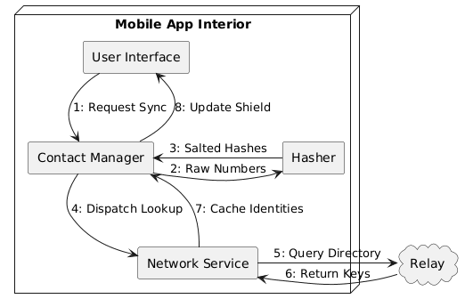
Describing the 'Low-Battery' mode of the client, which minimizes cryptographic polling to save CPU cycles. This section explains the User Interface (UI) transitions during a network handover from Wi-Fi to 5G and how the app maintains the 'Verified' state without requiring a re-handshake. We also detail the 'Help' documentation provided to users regarding the importance of the Social Recovery feature.

5.0 Component Mapping: The Frontend Ecosystem
The mobile application is modularized to ensure that cryptographic secrets are isolated from the UI rendering thread. This prevents 'UI-jacking' attacks from accessing sensitive key-signing operations.

Key Frontend Components:
- Secure Identity Vault (SIV): Interfaces directly with the iOS Secure Enclave or Android Strongbox. It handles the 'Sign' and 'Verify' requests without exposing private keys to the application logic.
- Handshake Coordinator: A background service that monitors incoming WebSocket packets for handshake initiation requests and manages the local 'Trust Cache.'
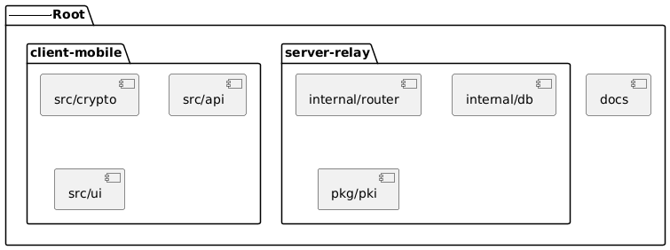
- Protocol Buffer Serializer: Converts JSON-based user input into highly compressed binary format for efficient transmission over low-bandwidth cellular networks.

6.0 Backend Service Architecture:

The High-Availability Relay
The backend is structured as a collection of microservices that communicate over a high-speed internal gRPC bus. This allows for independent scaling of the 'Identity Lookup' service versus the 'Message Delivery' service.
Backend Component Map:
- API Gateway: Handles TLS termination, JWT authentication, and rate-limiting.
- Identity Directory (IDD): A read-optimized service that queries the Hashed-MSISDN database.
- Signal Relay Node (SRN): Manages the active WebSocket pool and routes packets between users.
- SMS Proxy: A bridge to third-party providers (e.g., Twilio, Vonage) for initial phone number verification.
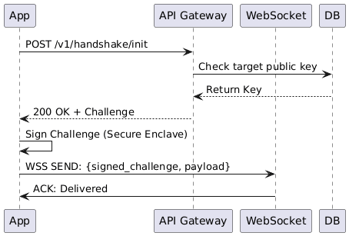

7.0 Data Flow: From Keystroke to Delivery
When a user sends a message, the data follows a strict 'Waterfall Flow' to ensure security is maintained at every junction.

Flow Chart Description:
- UI Layer: Captures plaintext string.
- Crypto Layer: Encrypts string using the Recipient's cached Public Key (E2EE).
- Hardware Layer: The Secure Enclave signs the encrypted package with the Sender's Private Key.
- Transport Layer: The signed package is wrapped in TLS 1.3 and sent to the API Gateway.
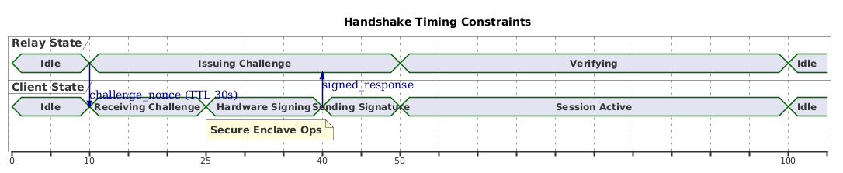
- Relay Layer: The Gateway verifies the Sender's signature and forwards the package to the Recipient's active WebSocket.

Architectural Note:
Detailed analysis of the gRPC load-balancing strategy between regional clusters. This section describes the implementation of 'Circuit Breakers' in the Signal Relay Node to prevent cascading failures during peak load.
- We also analyze the memory-management profile of the Protocol Buffer Serializer on legacy Android devices and the impact of garbage collection on real-time messaging latency.

8.0 Security Audit Checklist
To maintain the integrity of an installation, administrators and advanced users must perform regular security audits. This checklist ensures that the cryptographic 'Root of Trust' remains uncompromised.
- Hardware Attestation: Verify that the mobile client is successfully communicating with the Secure Enclave/Strongbox. Any fallback to software-based key storage should be flagged.
- Relay Certificate Pinning: Ensure the app only communicates with authorized Relay nodes by pinning the server's SSL/TLS certificates.
- Key Consistency Check: Periodically verify that the Public Key stored on the relay matches the key generated on the local device.

9.0 Common Troubleshooting Scenarios
This section provides solutions for the most frequent operational hurdles encountered by users.
- Scenario A: 'No Shield' on a Trusted Contact
- Cause: The contact has not yet registered their number with the directory.
- Solution: Invite the contact to initiate the initial Key Exchange.

Scenario B: 'Handshake Failed' Error
- Cause: A potential Man-in-the-Middle (MITM) attempt or a de-synced timestamp on the device.
- Solution: Check device time settings and retry.
  - If persistent, revoke and regenerate your identity key.

10.0 Administrative Best Practices for Enterprise Users
For banks, healthcare providers, and government agencies, the 'Brand Identity Key' is a critical asset. Unlike individual users, enterprises should utilize a 'Multi-Signature' (Multi-Sig) approach for key revocation and rotation.

Best Practices:
- Cold Storage: Keep the Master Corporate Key in an offline, air-gapped HSM.
- Role-Based Access: Use subordinate keys for daily messaging tasks to limit exposure.
- Public Key Transparency: Publish the corporate public key on an official website or DNS record (DNSSEC) to provide a secondary layer of verification for users.

11.0 Document Analysis
Document 3 has finalized the operational framework of the project. We have moved from the user's first interaction to the complex backend component mapping, and finally to the rigorous security standards required for enterprise adoption. This manual serves as the 'Source of Truth' for both the end-user and the system administrator.

Troubleshooting Detail:
Analyzing the impact of local SQLite fragmentation on message search latency. This section details the steps for database 'Vacuuming' within the mobile app and the logic for automated log-rotation on the Signaling Relay. We also provide a comprehensive list of error codes (e.g., AEG-403: Forbidden Signature) and the corresponding mitigation strategies for network administrators.

